**Work Flow of the project:**

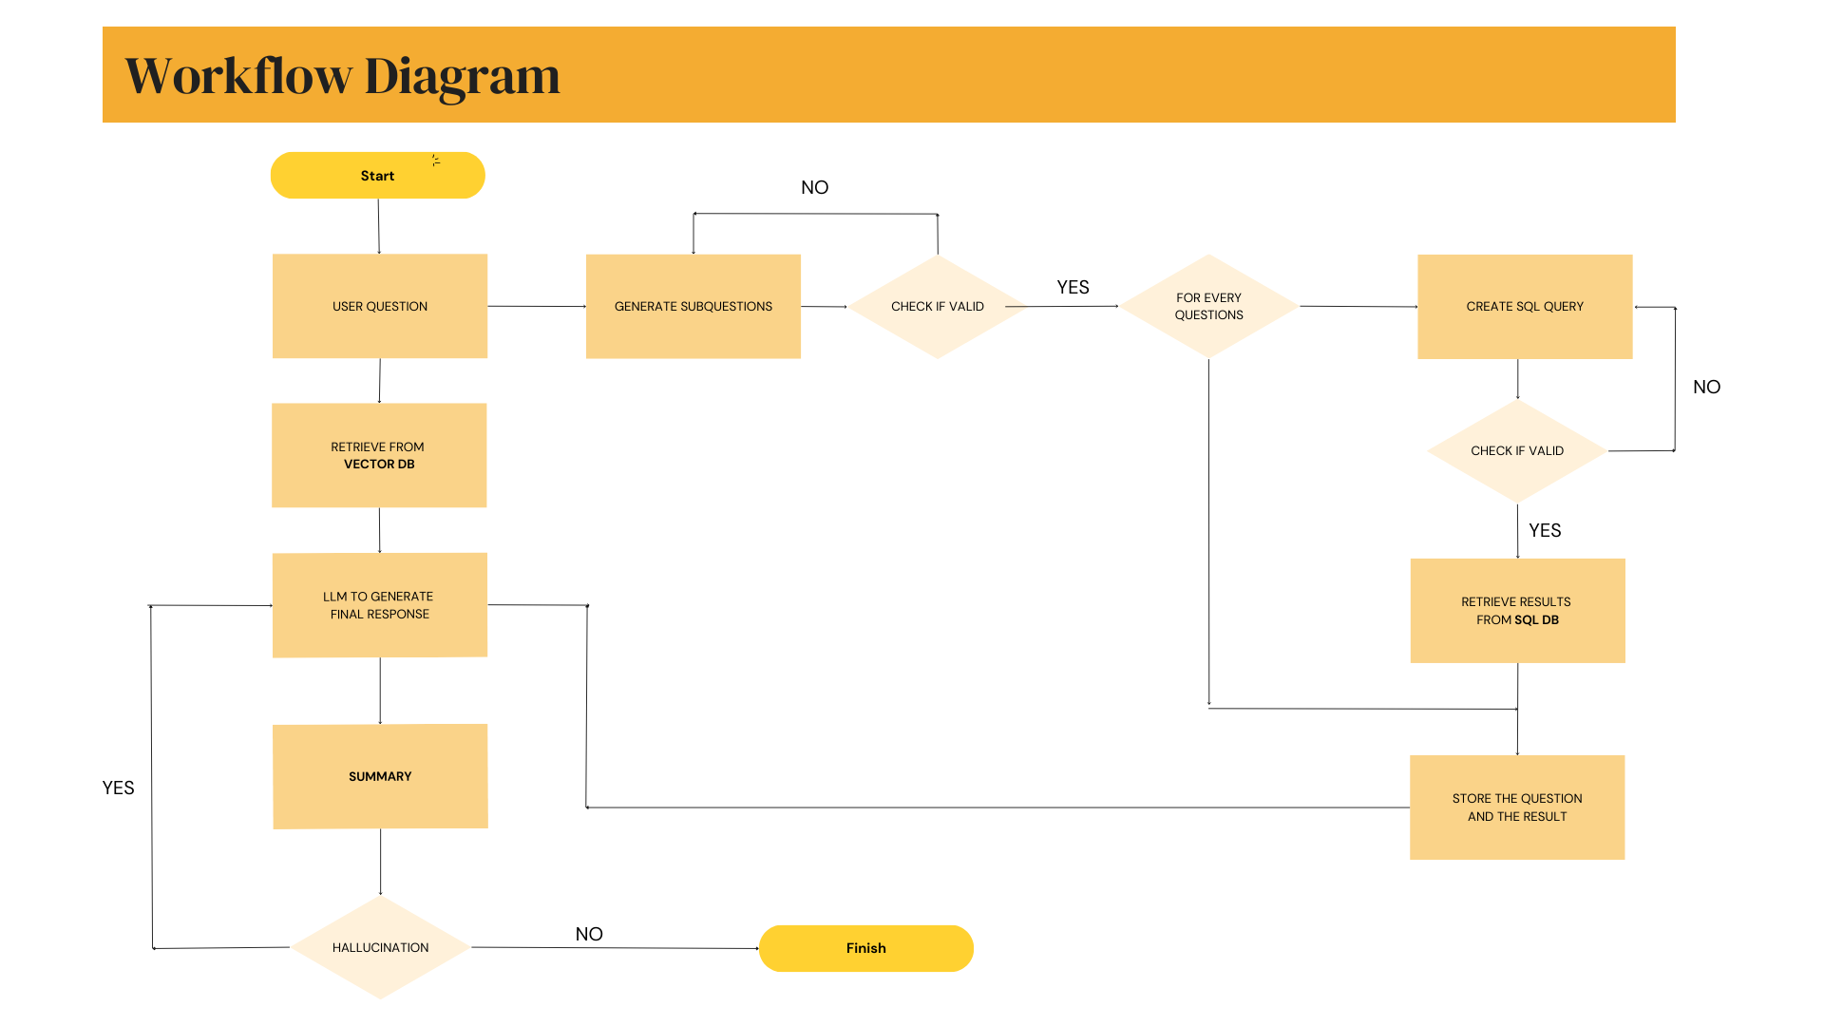

**1. Start**

The process begins when a user submits a question.

**2. Handling User Query**

* If the query requires direct retrieval, the system doesn’t generate sub-questions for the user question
* If the query needs decomposition, **sub-questions** are generated for it.

**3. Validating Sub-Questions**

* The system checks whether the generated sub-questions are valid.
* If invalid, the process retries at this step until it becomes valid .
* If valid, each sub-question is processed further.

**4.Historical Insights Retrieval from Vector DB**

* Retrieve a Historical Insight from the Vector Database based on the User Question , which is used for summary generation by the LLM in upcoming steps.

**5. SQL Query Execution**

* For each valid sub-question, an **SQL query** is generated using a LLM.
* The validity of the SQL query is checked. If invalid, the process retries by generating a valid SQL query.
* If valid, the query is executed, and results are retrieved from the **SQL Database**.
* The retrieved results are stored along with the corresponding question.

**6. Generating Final Response**

* The retrieved data is processed using the **LLM (Large Language Model)** to generate the final response.
* A **summary** of the response is generated.

**7. Checking for Hallucinations**

* The system verifies if the response contains hallucinations (incorrect or misleading information).
* If hallucinations are detected, the system loops back to refine the response.
* If no hallucinations are found, the workflow proceeds to completion.

**8. Finish**

* The final response is presented to the user.